S_ALR_87005722 -

Functionality
In this step you define the CO versions you want to use for your operating concern. These versions are valid for all of CO and for all operating concerns.
In Profitability Analysis, you can only use versions for plan data. Consequently, the fields "Actual" and "Exclusive use" are not relevant for CO-PA.
Each version has attributes, which are only valid for one operating concern.
The attributes determine the following:
- Whether you can plan a version
The Version locked indicator lets you lock a plan version so that no more changes can be made to it.
- Which currency type should be used to store the data in this version
If, alongside the operating concern currency, the company code currency or the profit center valuation is also active in your operating concern, you need to specify the currency type for each version.
- Which exchange rate should be used to translate foreign currencies to the local currency
- For what date the system should derive characteristics
In planning, the system always tries to derive values for the characteristics, which you do not specify. Since these derivation rules are time-dependent, you can specify which date the system should use when it performs derivation.

Scenario
Create plan version 4.

Requirements
Operating Concern

Menu Path | Accounting → Controlling → Profitability Analysis → Planning → Current Settings → S_ALR_87005722 - Maintain Plan Versions
Transaction Code | S_ALR_87005722

1. Double click on S_ALR_87005722 - Maintain Plan Versions.

General Version Definition

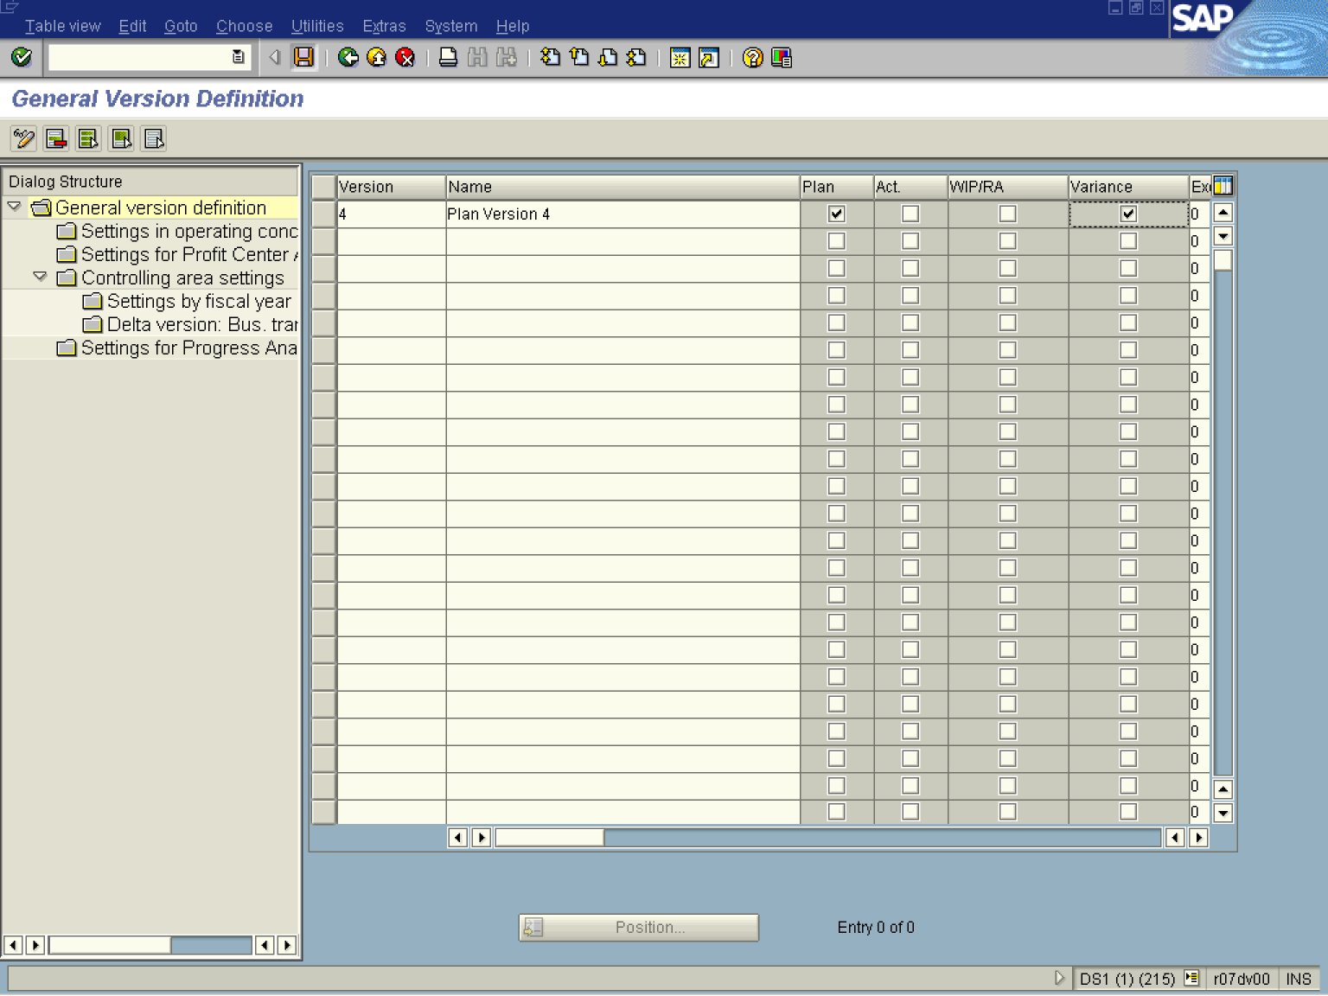

2. Click the New entries button.
3. Update the following fields:

Field Name | Field Description | Values
Version | Number key identifying plan version | Example: 4
Name | Description of the Name. | Example: Plan Version 4
4. Click the checkbox 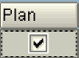 in the Column Plan to select it.
5. Click the checkbox in the Column Variance 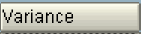 to select it.
6. Click the Save button.
SAP R/3

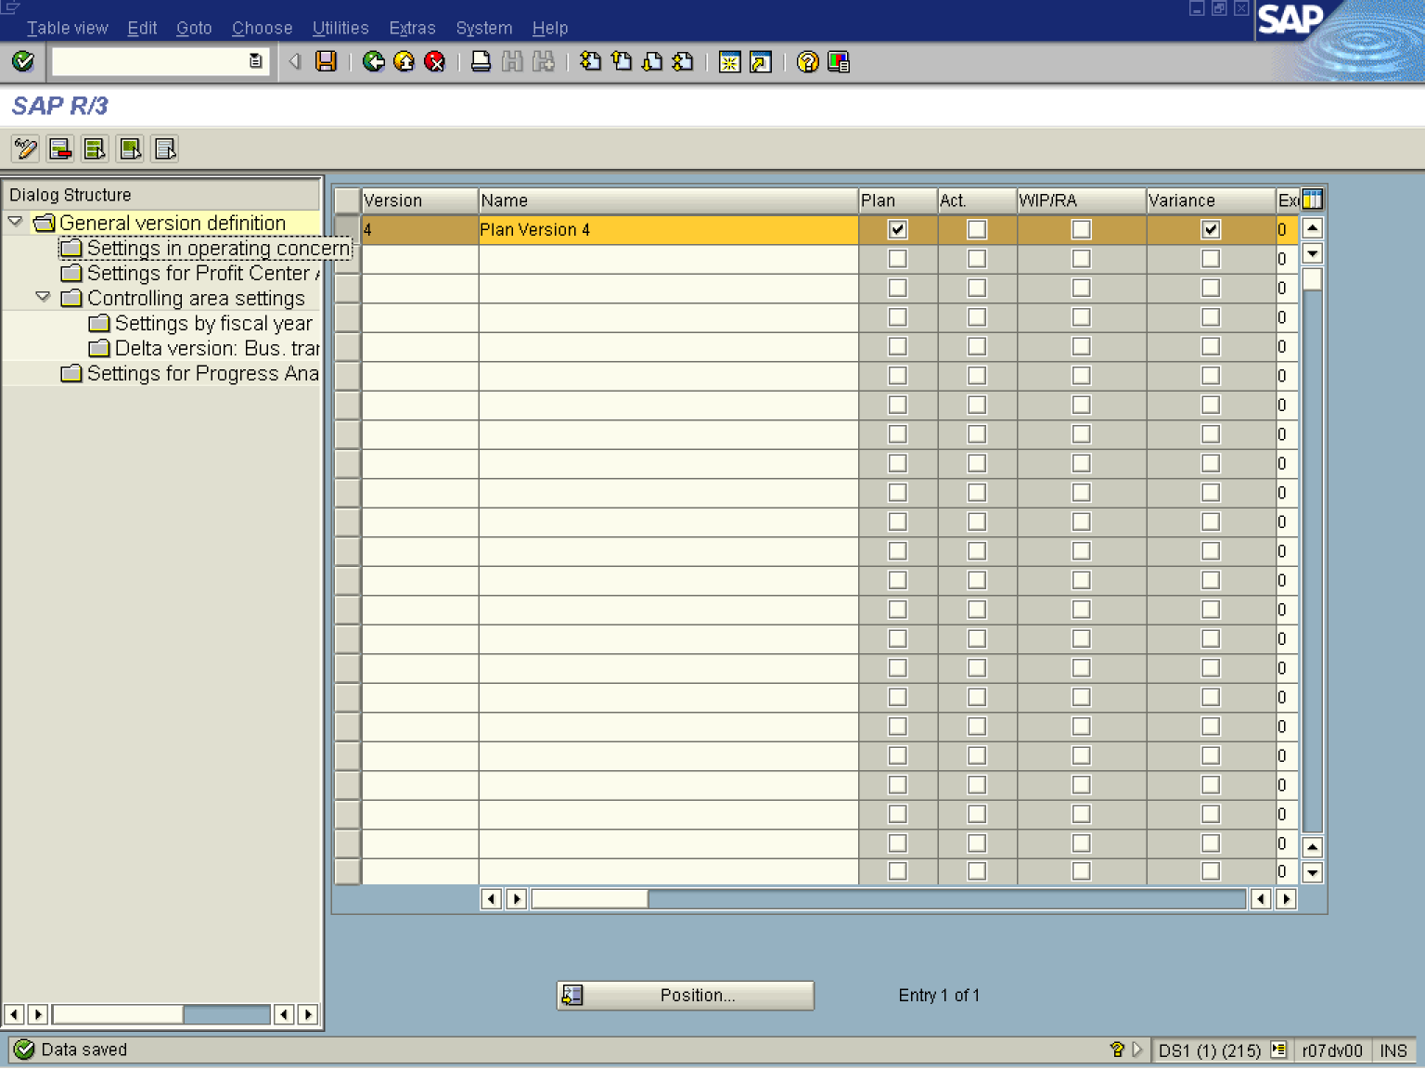

7. Select the 4 line and click the Settings in operating concern button.

Confirm transfer from version

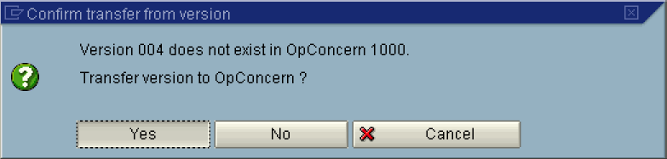

8. Click the Yes button.

Change View "Settings in operating concern": Details

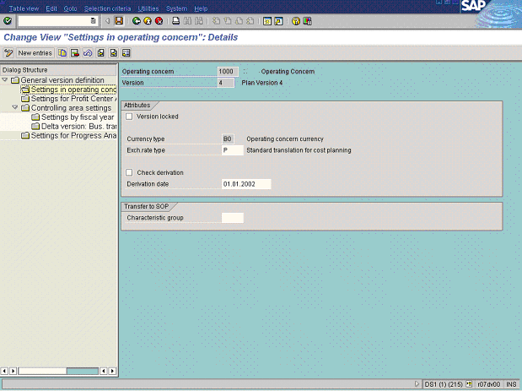

9. Update the following fields:

Field Name | Field Description | Values
Exch.rate type | Exchange rate type that will be used for currency translation. | Example: P
Derivation date | Date for derivation of characteristics in planning. | Example: 01.01.2002

10. Click the checkbox of the Check derivation to select it.
11. Click the Enter button.
12. Click the Save button.
13. The message bar displays “Plan version saved”

